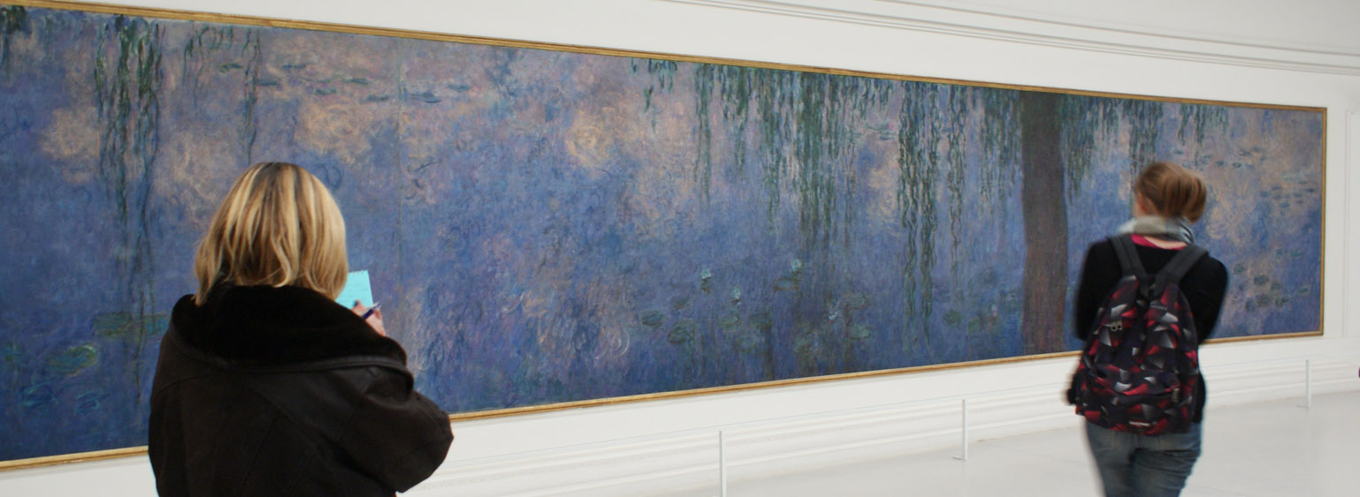
Ecole du Louvre

International
Program
2015

Introduction to French Museology :
focus on the Diversity of Parisian Museums
…………………………………………………………………………………………………………............................…….......…

Week one
Monday June 29
Introduction

10h00 am (Ecole du Louvre, Salle Nara)
Opening of the seminar and reception of students
Philippe Durey
general Heritage Curator, director of the Ecole du Louvre

10h30-12h30 am (Ecole du Louvre, Salle Nara)
Introduction to the museology: history and missions of the museum
Anne-Solène Rolland
curator, advisor of the president, Musée du Louvre

12h30-13h30 (administrative hall)
Buffet Lunch

Tuesday June 30
Mediation

10h30-12h00 am (Salle Nara)
Families at the Museum.
Anne Jonchery,
responsible for Research, Department of Public Relations, Ministry of Culture and Communication

11h30-13h00 am (musée en herbe)
Focusing on children: le musée en herbe
Adeline Brossart
Médiatrice culturelle au musée en Herbe.

Wednesday July 1
History and operation of the Louvre

9h30-11h00 (Ecole du Louvre, Salle Nara)
From a royal palace to a world famous museum : the Louvre
Françoise Mardrus
Project manager, Musée du Louvre

11h00-12h30 (Ecole du Louvre, Salle Nara)
Operation of a great museum: the Louvre.
Anne-Solène Rolland
curator, advisor of the president, Musée du Louvre

Thursday July 2
Exhibition - Integration day between Illinois and EdL Students

9h30-11h00 (Ecole du Louvre, Salle Nara)
Programming exhibitions at the RMN,
Philippe Platel,
deputy Chief of Exhibition Department, RMN-Grand Palais

11h00-12h30 (Ecole du Louvre, Salle Nara)
Scenography of exhibition (a case study of a forthcoming exhibition at the Grand Palais)
Philippe Platel,
deputy Chief of Exhibition Department, RMN-Grand Palais

12h30-14h00
Picnic with EdL students, Tuileries garden

14h30-15h30
Visit of an exhibition at the Grand Palais
Philippe Platel

Week two
Monday July 6
Conservation and Preservation

9h00-10h30 (Ecole du Louvre, salle Nara)
Preserving collections: the ethics of restoration
Florence Bertin,
curator in charge of conservation and restoration, musée des arts décoratifs

11h00-12h30 (C2RMF, pavillon de Flore)
○ A passport or ID card is required.
Please be on time.

The “C2RMF”, the center for Research and Restoration of the Museums
of France. General organisation and presentation of some current restoration.
Pierre Curie,
chief curator, in charge of the paintings, Conservation Department,
Centre de recherche et de restauration des musées de France

Tuesday July 7
Artist’s houses / Renovation of museum spaces
○ le musée national Eugène Delacroix is closed to the public on Tuesday. It will be exceptionally opened for our students.
Please be on time.

9h30-10h30 (musée national Eugène Delacroix-ateliers)
From artist’s studio to museum: artist’s houses
Dominique de Font-Réaulx
chief curator, musée du Louvre, Director of musée national Eugène Delacroix

11h00-12h30 (musée national Eugène Delacroix)
Practical Visit

14h15-15h45 (Ecole du Louvre, sale Nara)
Exhibiting the collections:
History and transformations of a train station into a museum: from the origins until today.
Alice Thomine-Berrada
curator, Musée d’Orsay

16h00-17h30 (Orsay muséum)
Practical Visit
Clémentine Lemire
assistant curator, Musée d’Orsay

Wednesday July 8
Integration morning at the Louvre and Contemporary Art issues

9h30-11h30
From a royal palace to a world famous museum (Practical Visit)
Laurence Tardy
lecturer, Ecole du Louvre

11h30-13h00 (Louvre Museum Visit)

14h15-15h45 (Centre George Pompidou)
Exhibiting contemporary art: Visit of the Pompidou Collections.
Baptiste Brun
Ph.D in history of art, lecturer, Ecole du Louvre

Thursday July 9
New tendencies: the museum of the future

9h00-10h30 (Agence France-Museums)
The Louvre Abu Dhabi: the first universal museum in the Arabian world. Conference and visit: the Agence France-Muséums
Jean François Charnier
curator, Scientific Director of the Agence France-Museums

11h00-13h00 (musée du Louvre)
The new arrangement of the collections in the Islamic Art department
And visit of the Exhibition “Birth of a museum Louvre Abu Dhabi “
Camille des Guerrots
lecturer, Ecole du Louvre

Week three
Wednesday July 15
Monument and historical building still operating

9h30-12h30 (Opéra de Bastille)
The National Opera of Paris: An over-all view of the institution and the discovery of the Paris Opera's technical and scenic installations.
Guillaume Laguitton
assistant to the Technical Director of the National Opera of Paris

13h45-15h15 (Ecole du Louvre, Salle Nara)
The problematic of mediation in French museums
Fanny Serain
responsable for médiation, Palais du Tokyo

16h00-17h30 (Musée national du Moyen-Age –Thermes et Hôtel de Cluny)
Cohesion between building, historic collections, and objects:
the Hôtel de Cluny and its thematic galleries.
Isabelle Bardiès-Fronty,
chief Curator, musée national du Moyen Age, Thermes et Hôtel de Cluny

Tuesday July 16
The case of Château-Museum

9h30-11h30 (musée du quai Branly)
Practical Visit
Aurélien Gaborit
courator, musée du quai Branly

14h30-16h30 (musée national du château de Versailles)
The case of Château-Museum:
visit to the musée national du Château de Versailles
Bertrand Rondot,
curator, musée national du Château de Versailles

Fiday July 17
Society Museum

11h00-12h00 (Cité nationale de l’histoire de l’immigration)
Society Museum: a place for history, a place for memory
Angeline Escafre-Dublet,
historian, Cité nationale de l’histoire de l’immigration

12h00-13h00 (Cité nationale de l’histoire de l’immigration)
Practical Visit
Hélène Bouillon
Curator, Cité nationale de l’histoire de l’immigration

14h30-16h30 (Ecole du Louvre, Salle Nara)
Discussion about the seminar and final exam.

