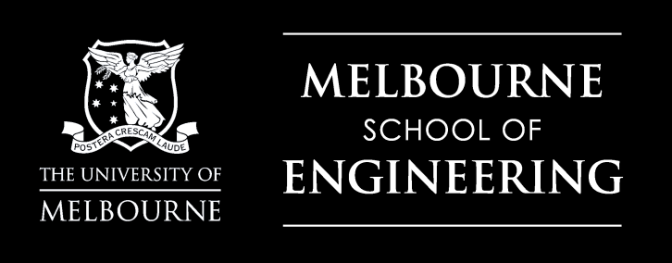

***Visit the University of Melbourne this Australian Summer***

**18-30 January 2016**

Peking-Melbourne

Science Summer School

2016

**The University of Melbourne**

The University of Melbourne’s annual Summer Camp is run for 2 weeks over the Australian Summer and provides an opportunity for Peking University students to experience life at Australia’s number 1 university.

This year the Faculty of Science program will focus on Computational Biology, Chemistry and Energy Systems and is open to 3rd and 4th year Peking University students from the following areas: Mathematics, Chemistry, Biology, Computer Science and Physics.

**About the program**

The 2016 Science Summer Camp will be hosted by the VLSCI (the Victorian Life Sciences Computation Initiative), the School of Chemistry and the School of Earth Sciences. The themes are Computational Biology, Chemistry and Energy Systems and include topics such as Human Genomics and Disease, Evolutionary Genomics and the Environment, Past Climates and Renewable Energy Systems.

Students attend lectures and workshops and experience Melbourne through a rich cultural and social program. They will also have opportunities to meet and network with undergraduate and graduate science students from the University of Melbourne.

**Program inclusions**

Participants will be hosted by the University of Melbourne for two weeks at the vibrant University College, which is located on campus. Most meals are provided, as well as airport transfers and a cultural tour.

**How to apply**

15 students from the areas of Mathematics, Chemistry, Biology, Computer Science and Physics will be selected on a competitive basis. You must be in your 3rd or 4th year of study, posses good English skills and already hold a valid passport (or will apply for a passport immediately upon being accepted into the Summer School).