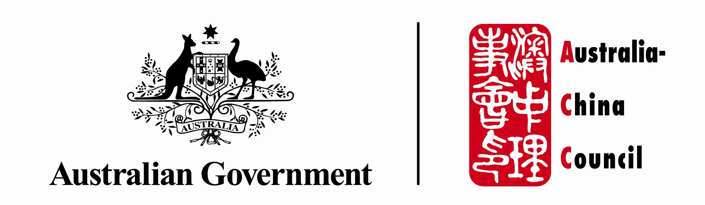


AUSTRALIAN STUDIES PROGRAM FUNDING CONDITIONS
- The purpose of this document is to set out the conditions attached to the funding that you will receive (if successful) from the Australia China Council (ACC).

- The funding agreement is between you (as the funding recipient) and the Australian Government, represented by the ACC, which is part of the Department of Foreign Affairs and Trade (DFAT).

- The ACC has engaged The University of Queensland (UQ) to manage the Australian Studies Program as our service provider. UQ will handle all aspects of the Competitive Projects and Output Awards as part of the Australian Studies Program, including initiating and receiving all correspondence, making payments and ensuring proper acquittals are done.

- In signing the Funding Acceptance Form, you agree to the following terms and conditions:

  - I/we must only use the money constituting the funding (i.e. the funds) for carrying out the project approved by the ACC;
  - I/we must not allocate to, or allow the funds to be used by, another person or institution, unless such allocation or use is part of the approved project;
  - I/we must not make any substantial changes to the scope of the approved project, without the prior written agreement of the ACC;
  - I/we agree that the funding is valid only for one year from the date of payment by the UQ to my/our nominated bank account. I agree and understand that if my/our project cannot be completed and acquitted within one year of payment, I/we agree, upon request by the UQ, to promptly repay the funds (or any unused part of the funds) to the UQ for repayment to the ACC;
  - I/we agree to acknowledge the funding support of the ACC when undertaking any activities for the project, or when undertaking activities for the part of the project funded by the ACC. I/we agree to ensure that this acknowledgement is located prominently in all publicity material prepared in relation to the project, including whenever possible display of the Council’s logo. I/we acknowledge that the ACC's logo can be downloaded from the ACC’s website at http://www.dfat.gov.au/acc/acc_downloads.html;
  - I/we must, upon completion of the project, or if the funding is terminated by the ACC in accordance with these conditions, promptly refund to the UQ any funds that have not been expended in accordance with the agreed project for repayment to the ACC;
  - I/we must within 30 days of completing the project, provide the UQ with a written report in the form of the Acquittal Report form attached to these conditions (Attachment B). I/we acknowledge that the ACC is entitled to take recovery action if, in the reasonable opinion of the UQ, ACC or the Department of Foreign Affairs and Trade, the funding has not been acquitted adequately;
  - Further to clause (g), I/we acknowledge that if I/we fail to provide to a satisfactory Acquittal Report within 30 days of the agreed completion date for the approved project, I/we may not be eligible for additional or future funding from the ACC;
  - I/we agree to indemnify and to keep indemnified the ACC, DFAT, its officers, employees and agents from and against all actions, claims, demands, costs and expenses (including the costs of defending or settling any action, claim or demand) made, sustained, brought or prosecuted in any manner based upon, occasioned by or attributable to any injury (including death) to any person or loss of or damage to property which may arise from or be a consequence of any unlawful or negligent act or omission by me/us and by my/our officers, employees or agents in carrying out the project.
  - I/we acknowledge and understand that the ACC may terminate my/our funding, and that the ACC may take action to recover moneys constituting the funding, if in the reasonable opinion of the ACC, the approved activities for which funding has been provided are not being carried out with competence and diligence or that I am/we are in breach of any provision in these conditions;
  - I/we acknowledge and understand that the ACC may, without prejudice to the availability of the remedy above, direct me/us to rectify any breach of these conditions within seven (7) days of receiving written notice from the ACC;
  - I/we acknowledge and understand that the ACC may withdraw its funding for my/our project before it transfers the funds to me/us where it no longer has sufficient funding allocated to the project within its own internal budget, notwithstanding that I/we have agreed to these conditions and signed the Funding Acceptance Form;
  - I/we acknowledge and agree that the information, including personal information, I/we have provided in the Funding Acceptance Form is used to facilitate my/our participation in the Australian Studies Program and that my/our information, including personal information, may be disclosed to officers, employees and agents of the ACC, DFAT and UQ;
  - I/we also acknowledge and agree that my/our details, including personal information, may be made public via the DFAT, ACC or UQ websites and that the ACC / DFAT may publish this information, including personal information, in its annual report; and
  - I/we acknowledge that in other circumstances, the ACC / DFAT will only use and/or disclose personal information in accordance with the Privacy Act 1988; and that the provisions of the Freedom of Information Act 1982 apply to documents in the possession of the UQ/ACC/DFAT.

