

Program

Chinese–Austrian EU-Summer School 2013

Venues include:

Munich / Salzburg / Venice /Vienna / Brussels / Paris

Group I

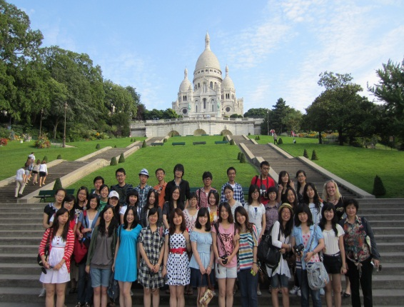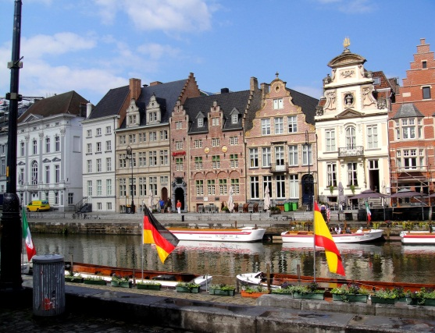

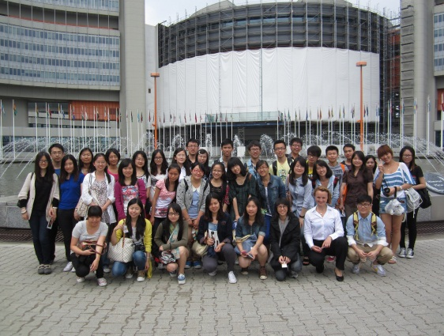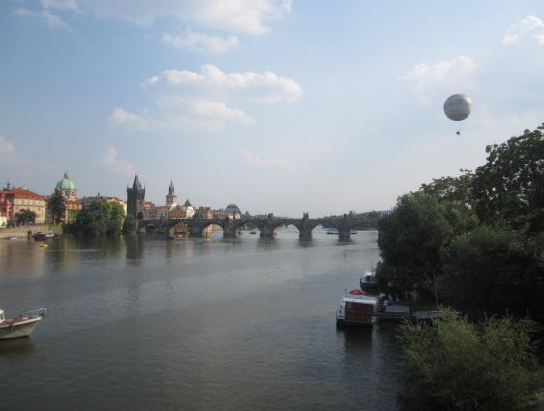

12th July – 08th August 2013

Coordination |
Kaigasse 28 | A- 5020 Salzburg
Mobile: +43 664 | Phone: +43 662
Fax: +43 662 | e-mail:
12th to the 18th of July 2013,Salzburg
Europa Kolleg Salzburg
Robert-Preußler-Straße 28
5020 Salzburg
Nr.:0043/662/930300
Friday, 12th of July | Munich/Salzburg
Flight from Beijing to Munich
Transfer from Munich to Salzburg
Arrival in Salzburg:
Late night Dinner (provided by FAGO)
Meeting Point: to be announced
Introduction – getting to know each other (must attend)
Saturday, 13th of July | Salzburg
07.30am - 08.30 am  09.10 am  10.00 am – 12.30 pm | Breakfast (provided by FAGO)  Meeting Point: Hotel Lobby – Leaving for the City  City Tour Salzburg (must attend)  Free Time
Sunday, 14th of July | Salzburg
 | Free Time
Monday, 15th of July | Salzburg
07.00 am - 08.00 am  08.15 am  09.15 am – 12.15 pm  12.15 pm – 01.15 pm  01.30 pm – 04.30 pm  04.45 pm  05.00 pm  05.30 pm – 06.15 pm  06.15 pm | Breakfast (provided b FAGO)  Meeting Point: Hotel Lobby - Leaving for the University NAWI (Hellbrunner Straße 34)  Lecture on Philosophy in Austria and Beyond with Prof. Gerhard Zecha, Department of Philosophy, University of Salzburg  (must attend)  Lunch break (Mensa/organised by oneself)  Lecture on Austrian law with Mag. Bernhard Brandauer, solicitor's office Dr. Gerwin Brandauer, Salzburg (must attend)  Transfer to Hellbrunn  Visit to the Castle Hellbrunn (must attend)  Visit to the Trick Fountains (must attend)  Transfer back to the City (either by Shuttle bus or individually)  Free Time
Tuesday, 16th of July | Salzburg
07.00 am - 08.00 am  08.15 am  09.15 am – 12.15 pm  12.15 pm – 01.30 pm  01.45 pm – 04.45 pm | Breakfast (provided b FAGO)  Meeting Point: Hotel Lobby - Leaving for the University NAWI (Hellbrunner Straße 34)  Lecture on Austrian History with Prof. Reinhold Wagnleitner, Department of History, University of Salzburg (must attend)  Lunch break (Mensa/organised by oneself)  Lecture on The Political System of Austria with Dr. Franz Fallend, Department of Political Science, University of Salzburg (must attend)  Free Time
Wednesday, 17th of July | Salzburg
07.00 am - 08.00 am  08.15 am  09.15 am – 12.15 pm  12.15 pm – 01.30 pm  01.45 pm – 04.45 pm | Breakfast (provided b FAGO)  Meeting Point: Hotel Lobby - Leaving for the University NAWI (Hellbrunner Straße 34)  Lecture on Austrian Literature with Dr. Siegrid Schmidt and Dr. Eder, Department of German Studies, University of Salzburg  (must attend)  Lunch break (Mensa/organised by oneself)  Lecture on Austrian History of Music with Prof. Wolfgang Gratzer from Mozarteum University Salzburg (must attend)  Free Time
Thursday, 18th of July | Salzburg/Lake District
07.00am - 08.00 am  08.15 am  09.00 am – 11.00 am  11.00 am – 12.00 am  12.15 pm  01.15 pm – 03.00 pm  04.00 pm – 05.00 pm  05.30 pm – 07.00 pm  07.30 pm | Breakfast (provided b FAGO)  Meeting Point: Hotel Lobby - Leaving for the University NAWI (Hellbrunner Straße 34)  EXAM – Lectures in Salzburg (must attend)  Lunch break  Transfer to Lake Wolfgang (must attend)  Visiting the Schafberg Mountain  Boat Tripp on the Lake Wolfgang  Dinner at Fischer Wirt. St. Gilgen, hosted by the Chinese-Austrian Studies Centre Salzburg  Transfer back to Salzburg
19th to the 21th of July 2013,Italy
All Seasons Venezia Marghera
Via Malamocco 14
30175 Mestre
Nr.: (+39)041/5380968
Friday, 19th of July | Salzburg/Tyrol/Italy
07.30 am - 08.30 am  08.45 am  10.30 am – 02.00 pm  02.15 pm  06.00 pm | Breakfast (provided by FAGO)  Meeting Point and transfer to Wattens, Tyrol  Visit to Swarovski Crystal World (including Lunch – provided by oneself)  Meeting Point at the bus and transfer to Italy  Arrival at the Hotel  Free Time
Saturday, 20th of July | Venice
Until 08.30 am  08.50 am  09.00 am – 09.30 am  10.00 am – 12.00 pm  12.30 pm | Breakfast (provided by All Seasons)  Meeting Point: Hotel Lobby  Transfer to Venice  City Tour Venice (must attend)  Free Time
Sunday, 21st of July | Italy
Free Time
(possibility to revisit Venice – Transfer service from the hotel)
22nd to the 28th of July 2013, Vienna
IBIS Mariahilf Wien
Mariahilfer gürtel 22-24
1060 Wien
Nr.: 0043/1/599980
Monday, 22nd of July | Italy/Vienna
Until 08.30 am  08.45 am  09.00 am  Approximately 05.00 pm | Breakfast (provided by IBIS Vienna)  Meeting Point: Hotel Lobby  Transfer to Vienna  Arrival in Vienna
Tuesday, 23rd of July | Vienna
Breakfast (provided by IBIS Vienna)
Meeting point: Hotel Lobby – leaving for the WU (Augasse 2-6, 1090 Vienna)
Lecture on (must attend)
Lunch (organized by oneself)
Meeting Point
Transfer to the Musikverein (Musikvereinsplatz 1, 1010 Vienna)
Tour through the Musikverein (must attend)
Free Time
Wednesday, 24th of July | Vienna
Breakfast (provided by IBIS Vienna)
Meeting Point: Hotel Lobby – leaving for the Austrian Federal Ministry
Lectures at the Austrian Federal Ministry for European and International Affairs with……(Minorittenplatz 8, 1010 Vienna) (must attend)
Free Time (possible lunch)
Meeting Point (in front of the Tube station) – leaving for the House of Music
House of Music (must attend)
Free Time
Thursday, 25th of July | Vienna
Breakfast (provided by IBIS Vienna)
Meeting Point: Hotel Lobby – leaving for the WU
Lectures at WU (must attend)
Lunch
EXAM – WU Lectures (must attend)
Meeting Point and Leaving for the VIC (Visitor Information Center at the Uno City)
VIC (must attend)
Free Time
Friday, 26th of July | Vienna
Breakfast
Meeting Point: Hotel Lobby – leaving for Schönbrunn
Visit of Castle Schönbrunn (must attend)
Free Time
Saturday, 27th of July | Vienna
Free Time
Recommendations:
Czech Republic: Trip to Prague possible
Vienna: Central Cemetery, Danube Island or a visit to the Amusement Park “Prater
Lower Austria: Wachau with Melk and Dürnstein
Sunday, 28th of July | Vienna
Free Time
Recommendations:
Czech Republic: Trip to Prague possible
Vienna: Central Cemetery, Danube Island or a visit to the Amusement Park “Prater
Lower Austria: Wachau with Melk and Dürnstein
29th of July to the 04th of August 2013, Brussels
IBIS Brussels Centre Ste Catherine
Rue Joseph Plateau Nr. 2
1000 BRUSSELS
Nr.: (+32)2/6200426
Monday, 29th of July | Brussels
Breakfast (provided by IBIS Vienna)
Meeting Point: Hotel Lobby and Transfer to the Airport Vienna
Flight from Vienna to Frankfurt and
from Frankfurt to Brussels
Transfer to the Hotel
Tuesday, 30th of July | Brussels
Until 09.00 am  09.10 am  10.00 am – 12.00 pm  12.00 pm – 01.00 pm  01.10 pm  02.00 pm – 04.00 pm  04.15 pm | Breakfast (provided by IBIS Brussels)  Meeting Point: Hotel Lobby and leaving for the Permanent Representation of Austria to the EU  The Permanent Representation of Austria to the EU (30, Avenue de Cortenbergh – 1040 Brussels) (must attend)  Lunch Break (provided by oneself)  Meeting Point: to be announced and leaving for the Council (Rue de la Loi 175, 1048 Brussels)  Visit to the EU Council (must attend)  Free Time
Wednesday, 31st of July | Brussels
Breakfast (provided by IBIS Brussels)
Meeting Point: Hotel Lobby and leaving for the European Parliament (Rue Wiertz 60, 1047 Brussels)
Visit to the European Parliament (must attend)
Lunch Break (provided by oneself)
Meeting point and Transfer to EU Commission (Rue van Maerlant 2, 1040 Brussels)
Visit to the EU Commission (must attend)
Free Time
Thursday, 01st of August | Brussels/Luxembourg
Breakfast (provided by IBIS Brussels)
Meeting Point: Hotel Lobby
Transfer to Luxembourg
Free Time in Luxembourg
Meeting Point: Bus station
Transfer back to Brussels
Friday, 02nd of August | Brussels/Amsterdam
Breakfast (provided by IBIS Brussels)
Meeting Point: Hotel Lobby
Transfer to Amsterdam
Free Time in Amsterdam
Meeting Point: Bus station
Transfer back to Brussels
Saturday, 03rd of August | Brussels/Bruges/Gent
Until 08.45 am  08.55 am  09.00 am – 12.00 am  12.00 am – 01.30 pm  01.35 pm  01.40 pm – 02.20 pm  02.20 pm – 04.30 pm  04.35 pm  04.35 pm – 05.25 pm  05.25 pm – 07.00 pm  07.05 pm  07.10 pm | Breakfast (provided by IBIS Brussels)  Meeting Point: Hotel Lobby  Guided Tour through Brussels (must attend)  Free Time (Lunch provided by oneself)  Meeting Point: Hotel Lobby  Transfer to Bruges  Free Time in Bruges  Meeting Point: Bus  Transfer to Gent  Free Time in Gent  Meeting Point: Bus  Transfer back to Brussels
Sunday, 04th of August | Brussels
 | Free Time
05th to the 08th of August 2013, Brussels
IBIS Paris Bastille Opera
15 Rue Breguet
75011 – PARIS
Nr.: (+33)1/49292020
Monday, 05th of August | Paris
Until 09.00 am  09.45 am  10.00 am – 03.00 pm  03.30 pm | Breakfast (provided by IBIS Paris)  Meeting Point: Hotel Lobby  Transfer to Paris (one lunch stop – provided by oneself)  Free Time  Recommendation: Arc de Triomphe, Notre-Dame; Louvre, Eiffel Tower, Galeries Lafayette, Champs-Élysées, Sacré Coeur, Moulin Rouge
Tuesday, 06th of August | Paris
Until 08.45 am  08.55 am  09.00 am – 12.00 pm  12.30 pm | Breakfast (provided by IBIS Paris)  Meeting Point: Hotel Lobby  Guided Tour through Paris (must attend)  Free Time
Wednesday, 07th of August | Paris
08.25 pm  08.30 pm | Breakfast (provided by IBIS Paris)  Free Time  Recommendation: Trip to Gardens of Versailles  Meeting Point: to be announced  Ending Discussion: Reflection about the Summer School (must attend)
Thursday, 08th of August | Paris
Breakfast
Meeting Point: Hotel Lobby
Transfer to the Airport
Fligth from Paris to Munich
Flight from Munich to Beijing

